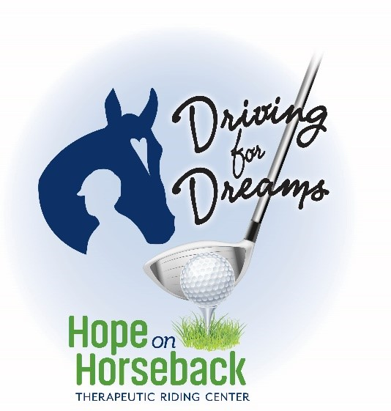

Sixth Annual Golf Tournament
Mound Grove Golf
10760 Donation Road, Waterford
Tuesday, July 15
10:00 AM Shotgun Start

Sixth Annual Driving for Dreams
Golf Tournament
Please consider becoming a sponsor or supporting this program for a deserving and underserved population in our community. This tournament is our signature event each year and guarantees that we will be able to include anyone who wants to take part in our programs despite their ability to pay.

Hope on Horseback Therapeutic Riding Center
Since 1981 Hope on Horseback has offered therapeutic riding classes which enhance the physical, mental, emotional and social well-being of individuals with special needs. Programs are offered for children and adults ages 6 to 80. Classes are provided for children and adults with physical and cognitive challenges as well as victims of abuse and trauma from the Erie Crime Victims Center. New programs will be offered this year to introduce the use of Equine-Assisted Learning in working with small groups in teamwork and leadership workshop. You can help with a donation of cash, goods or services. We will be happy to pick up any items that you wish to share.

Company___________________________________________________________________________________

Contact____________________________________________________________________________________

Address______________________________________________City_____________State_____Zip_________

Phone____________________ Email________________________________________________________

Donation_______________________________________________________________________________________________________________________________________________________________________________________________________________________________________________________________________________________________________________________________________________________________________

Contact:
Marlene Dombrowski
(814) 651-5172

